Meta Title:
Social Media Marketing Agency Dubai, UAE | ﻿TAM
Meta Description:
Three Angle Marketing (TAM) is a leading social media agency in Dubai that offers innovative and custom social media solutions. Get in touch to learn more!
social media marketing | 2400 | 88
social media agency Dubai | 1000 | 23
social media marketing agency in Dubai | 1000 | 28
best digital marketing agency in Dubai | 880 | 40
Social Media Marketing Dubai | 720 | 25
Social Media Marketing Agency | 590 | 39
digital marketing services | 590 | 47

social media marketing agency Dubai
social media agency Dubai
Social Media Marketing Dubai
social media marketing company Dubai
Social Media Marketing Services Dubai
Dubai social media agency
Dubai social media marketing
social media company in Dubai
Social Media Management Dubai
SMM company
SMM Dubai

Social Media Marketing Agency in Dubai
Is your brand facing challenges in keeping up with the latest trends or lower engagement rate? That’s where our social media management agency comes into play which specializes in lead generation, conversion rate, brand awareness, growth and search ranking by working on key aspects like social media strategy, target audience, customer outreach and relationship building.

Book a Free Consultation!

Want to Make Your Social Posts Exciting & Engaging?
Is your brand still struggling to leave a prominent market in the digital market? Don’t know where to start. Say bye to your worries, and contact Three Angle Marketing (TAM), the best digital marketing agency in Dubai to transform your channels into money-making machines. Wondering how we will do that? Here are different ways through which social media experts make your social post more engaging:

Use High-Quality Visuals | Frequent Posting
We use only high-quality visual content in the form of images, graphics and video to keep readers engaged and convince them for action. | Our social media handlers will post on trends and topics about your niche on alternative days of the week to keep your brand relevant.
Utilize User Generated Content | Keep Audience Engaged
To build your brand reliability in the market, our experts post original and brand-specific content crafted by customers on social channels. | To keep your audience engaged with your brand, our experts ask relevant questions and provide answers to the customer's queries.
Track Performance | Go Live
In order to keep your brand on track, our social media experts track the weekly performance of current strategies by measuring relevant KPIs. | To increase engagement and real-time interactions with your customers, we go live on your social media to raise awareness about your business.

Benefits of Social Media Marketing Services: What to Expect
SMM services offer many diverse advantages for newly established startups and growing brands in the market. The right social media marketing plan and monitoring system can take your market level to the next level. This way, you can increase brand loyalty, improve customer engagement level, and upgrade ranking & conversion rate.
Let’s dive into the benefits that you can gain when you get our social media marketing services in Dubai.

Improve Engagement Rate | Increase Conversions and ROI
Through the implementation of our bespoke solutions and the development of a unique approach to social media, our Social Media Marketing Agency in Dubai helps to foster better relationships. Allow us to assist you in building a bigger online presence. | PPC advertising on social media platforms is not only focused on getting more brand awareness but also more conversion and ROI elevation. Our Dubai social media agency assists with advertising to make it successful for you, based on research data.
Create Community Engagement | Work on Organic Marketing
Build true rapport with your target audience by availing of our community management solutions. This way our social media agency Dubai interacts with your followers, answers questions, and ensures an active and dedicated audience for your brand. | Our organic social media marketing services focus on making your brand popular through quality content that can be reposted across different social media channels! Remember, our social media marketing Dubai agency can help you get leads and also make your brand heard!
Diverse Marketing Options | Better Brand Control
Social media is not limited to Facebook, Instagram, YouTube and LinkedIn. There are many other options available through which you can promote your business. From What'sApp to Snapchat and Pinterest to Twitter (X), our experts will determine the right platform for your brand. | All of our social media packages are customized to meet the diverse needs of our clients. You have the full freedom of control from budget to branding concerning social media strategies. In this way, you can opt for a packaging that is most suitable to your pocket and needs.

Say Goodbye to Your Social Media Problems With our Perfect Solutions:
Are you getting tired of losing countless opportunities for engagement? TAM end-to-end Dubai social media marketing solutions can help you rewrite the entire script of your brand. From social media management to engaging content creation, our SMM company tackles every problem and ensures you get the desired results without breaking the bank. See below how we solve your social media problems with our expert social media services:

Social Media Management | Social Media Advertising
Experience our comprehensive social media management services which include daily account management to the arrangement of your posts. With the help of our customized posts, and engaging with your target audience at the right time, we make sure that your social media is up and running, while you handle the nitty-gritty of your business. | Take advantage of paid advertising by using our wide expertise in social media advertising solutions. Discover the wonder of Story Ads, unleash the best with Reels Marketing, and leave it to us and our strategic planning to ensure that your brand is busy growing with expertly crafted ads that fit the needs of the best audience.
Content Creation Services | Social Media Analytics and Optimization
Utilize our custom Social Media Content Creation Services & solutions to communicate to the right audience of your brand. Moreover, we deliver messages through genuine, passionate, and engaging visuals such as user-generated content as well as professionally tailored creativity to capture your audience’s interest in the best possible manner. | Maximize your social media experiences with our informational services focused on revealing the hidden capabilities of your investment. We do that by monitoring Social Media Metrics like the Click-Through Rate (CTR), Engagement Rate ,and all other markers to assess the Return on Investment (ROI) of each campaign to avoid random directions.

Social Media Audit
Get your social media brand profiles to the state of readiness for optimum functionality through our comprehensive social media audit and optimization services. Our careful step-by-step work ensures that your accounts are targeting all relevant groups and individuals so that they reach them and consequently, gain increased brand credibility.

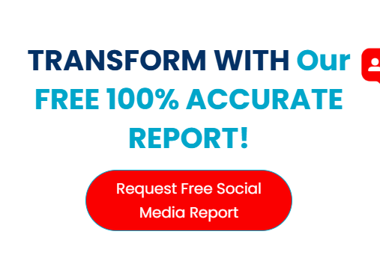

Ready to Transform Your Social Campaigns With Our Accurate Reports?

Request Your Social Media Report!

Digital marketing channels TAM Work With:
At TAM, our social media marketing Dubai experts understand very well the fact that the audience of each social media channel has specific needs. With one uniform custom social media strategy it's impossible to cater to all needs of diverse social media platforms. That’s why our social media marketing company in Dubai develops platform-specific content and strategies to get your desired audience. Whether you want to get benefits for paid marketing or run different lead-generation campaigns, our agency can help you achieve your goals. Given below are different social media platforms on which we have expertise

Facebook Marketing | Looking at some of the most active users all over the world, FACEBOOK cannot be ignored when it comes to putting your brand out there. Our professional control and creative solutions meet every individual marketing requirement for further brand development and attracting the audience.
Instagram Marketing | Whether you need a visually engaged audience, product placement, or collaborations with influencers, our Instagram marketing services drive your brand forward. Engage your visuals and stories on one of the most visually dynamic platforms.
LinkedIn Marketing | LinkedIn is not a job-finding platform but it is a great place for B2B marketing. Tap into our LinkedIn marketing services to create business connections, and sales opportunities as well as market your business as a reputable company in your niche.
TikTok Marketing | The new hype, TikTok, is a grenade out there waiting to be exploded. At TAM, we illustrate how our TikTok marketing services allow your brand to seize the trend and give your audience the content they crave.
Snapchat Marketing | If your target audience is mostly young people, our Snapchat marketing services present your brand as an opportunity to engage with potential customers teasing them with content that disappears within seconds.
YouTube Advertising | Google’s YouTube provides a potentially large receptive market for advertising. Collaborate with us for effective and engaging video advertisement creation, learn how to effectively use YouTube playlists, and extend communication opportunities.
Pinterest Marketing | Pinterest marketing services offered here assist lifestyle and product-related companies to navigate the site’s target focus as a visually appealing curation. To help you get more traffic and activity, everything is pinned and looks great.
Reddit Marketing | The contrived world of Reddit is far from being innocent. TAM Reddit marketing services allow you to participate in specific subreddits and guide discussion, opening the door to genuine brand relationships.
Twitter (X) Marketing | With our Twitter marketing agency in Dubai, you can also harness the true power and potential of one of the biggest and most influential social platforms. From optimizing your Twitter profile to sharing compelling tweets, our Twitter experts always have your back in all matters.
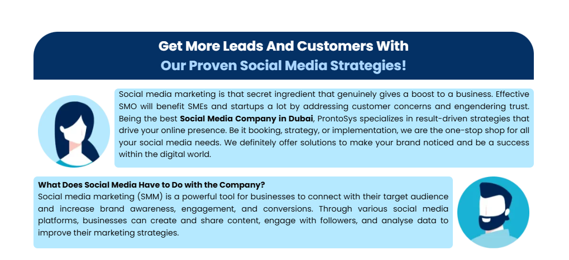

Get More Leads and Generate Higher ROI With Our Proven Strategies:

Dynamic Approaches, a Local Perspective | Delicate, Effective, Long-persisting strategies
Complementing the rich cultural environment of Dubai, our marketing communications effectively and meaningfully present the campaigns. We work closely with viral campaigns, oriented to the principles of social commerce, and incorporate Augmented Reality (AR) Ads into your projects. | Given our perfect apprehension of the market vibrate, we design campaigns, which are not only unconventional but business-oriented as well. Being a cutting-edge company we keep track of the most recent trends and present you with catchy and effective social media campaigns.

Let’s Collaborate To Transform Your Digital Presence!
The working process that we follow at Three Angle Marketing (TAM) can help you reap all the benefits of SMM without the investment of any extra penny. We transform the digital presence of our clients by implementing our data-driven strategies, which makes us the best Social Media Management Dubai company. Our winning transformational strategies involve:

Brainstorming Concepts | Clients Analysis | Innovative Designs
Our social media strategists and professional creators create different ideas and concepts with the help of analytical data to drive results and upgrade brand visibility factors. | After proper analysis of our client's business perceptions and psyche, our experts chalk out a strategy to turn them into loyal clients. In this way, you can increase your fan base. | Through the help of our graphic experts, we will impart growth to your brand by adding innovation and uniqueness to developed designs and User-Generated Content (UGC).
Select Marketing Medium | Create Campaigns | Set Desirable Goals
All social media can't work efficiently. So, our experts take the desired action by choosing the right medium to promote products and services effectively. | Moreover, Our experts will craft single and multiple data-driven campaigns for your brand based on your goals, target audience, and budget. | As per your advertisement budget, our strategist will set desirable and achievable social media goals for your brand in the most effective way.

Ready To Create Buzz On Social Media Platforms?
Take your business to the next level through TAM’s excellent social media marketing services in Dubai. Learn more about our services and discover the difference TAM can make for your business. Our team of experts is dedicated to boosting your brand's presence and engagement across all social media platforms.
Get your free social media audit report, and let us help you become one of the top brands in Dubai's social media landscape. Contact us today to see how we can transform your brand.

Get In Touch!

SMM FAQs
- What exactly is SMM?
SMM (Social Media Marketing) helps marketers to create interaction with existing or potential clients through social platforms like Facebook, Instagram, and Twitter, hence branding.
- How do social media strategies support digital marketing?
Our social media marketing Dubai strategies complement other digital marketing techniques by providing the organization with different channels to reach customers, advertise brands, and post content. This is important in accomplishing the overall objective of digital marketing in Dubai.
- What are the steps to initiate for small businesses?
Begin by defining the goal of your brand, then identify the target audience and the platform, and at the end frequently create unique and pertinent content.
- How can you measure the effectiveness of SMM in Dubai?
Here are the different ways through which our social media experts measure the effectiveness of current SMM strategies and campaigns:
- Establish Specific Goals
- Social Media Optimization (SMO)
- Key Performance Indicators (KPIs)
- Measure Return on Investment (ROI)
- Analyse Website Traffic and Conversions
- Evaluate Content Performance
- Why is TAM considered the leading SMM company in Dubai?
TAM is considered the best social media management Dubai agency because of its strategic market knowledge, dedication to clients, and success in achieving marketing targets through efficient and customized SMM strategies in Dubai.
- Which social media is most popular in Dubai?
Instagram and Facebook are the two of the most influential social media platforms in Dubai that provide several opportunities to share information with the audience and brand promotion at the same time.
- How much does a social media agency cost in Dubai?
The price of a social media company in Dubai depends on its service provisions, ranking, and type of business. It varies from a few thousand dirhams per month for simple services to thousands of dirhams for social media management and advertising.
- Which is the best Social Media Agency in Dubai, UAE?
TAM is considered among the top Dubai social media marketing agencies, as it effectively identifies the key strategies and plans to provide its clients with the best solutions and obtain the most effective results in marketing campaigns.
- Why is TAM your best SMM agency in Dubai?
TAM is the leading social media marketing agency in Dubai because it specializes in regional markets, custom solutions, and client results. Their emphasis on custom and performance gives them a competitive advantage for clients, especially when designing and implementing their marketing strategies.
- How will Social Media Advertising and Media Services benefit my business?
Social media advertising is advantageous for your business as it promotes brand awareness, website traffic, leads, and sales. With specific targeting options and Influencer Marketing, you can hit a certain audience, build interest in a particular product or service, and have a high ROI. This is especially true on highly active platforms such as Facebook, Instagram, and Twitter in Dubai.

